YOUR NAME OR COACHING COMPANY NAME

123 Street Address, City, ST 00000 | (000) 000-0000 TEL | (000) 000-0000 FAX

www.YourSite.com | YourEmail@YourSite.com

THE WHEEL OF LIFE FORM

THE TEN SECTIONS IN THE WHEEL OF LIFE represent balance and harmony in all areas of one's life. The CENTER of the wheel is assigned 0 points, with the outer far edge 10 points. Rank your level of satisfaction, happiness and/or fulfillment in each area by drawing a straight or curved line to create a new outer edge (SEE SAMPLE BELOW). The new perimeter of the circle will give you a visual idea of what areas you might want to focus on with your coach. Narrow down 1-3 areas you can work on to achieve greater satisfaction, happiness and/or fulfillment in your life in those areas.

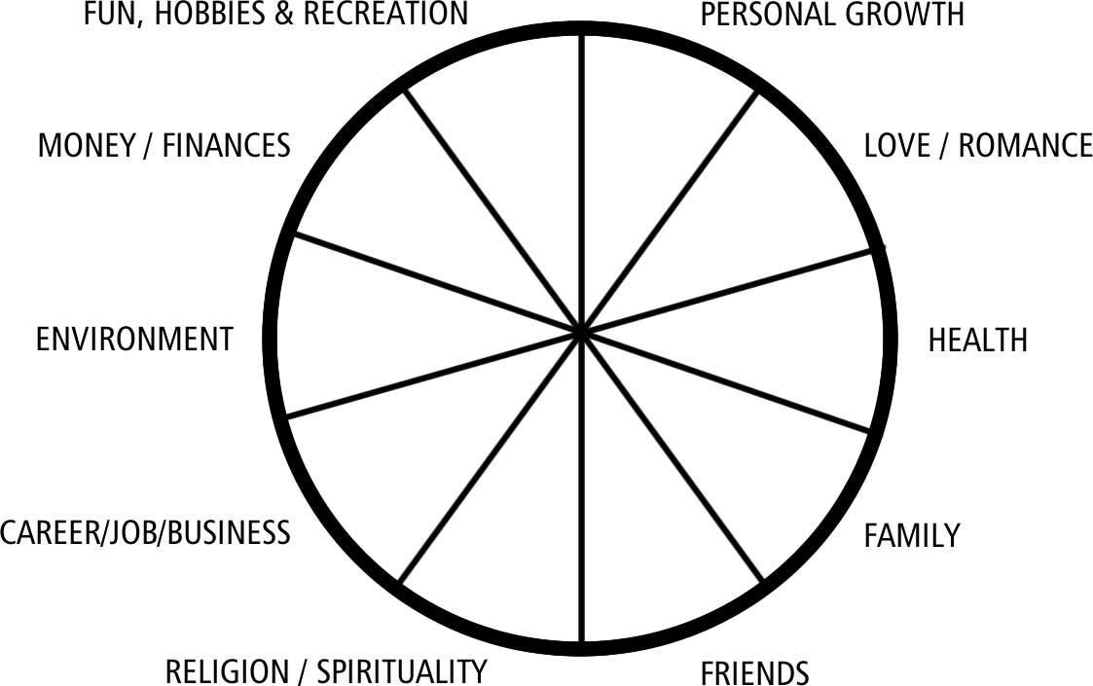

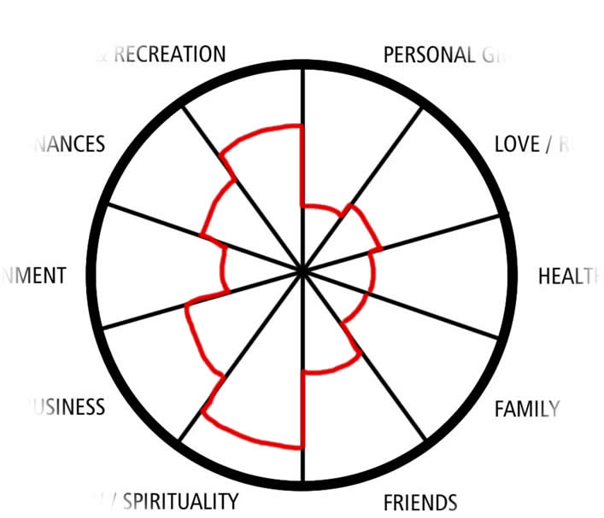
As you can see, on the right, is an example of how you would draw new perimeters on your wheel of life.

Where there is less happiness/satisfaction/fulfillment in certain areas, those would be the "areas of life" or topics you might discuss with your coach.

Again, pick out 1-3 areas to work on and focus on those for a few months with your coach to see if positive change can result from taking the right steps in the direction you want to go.

