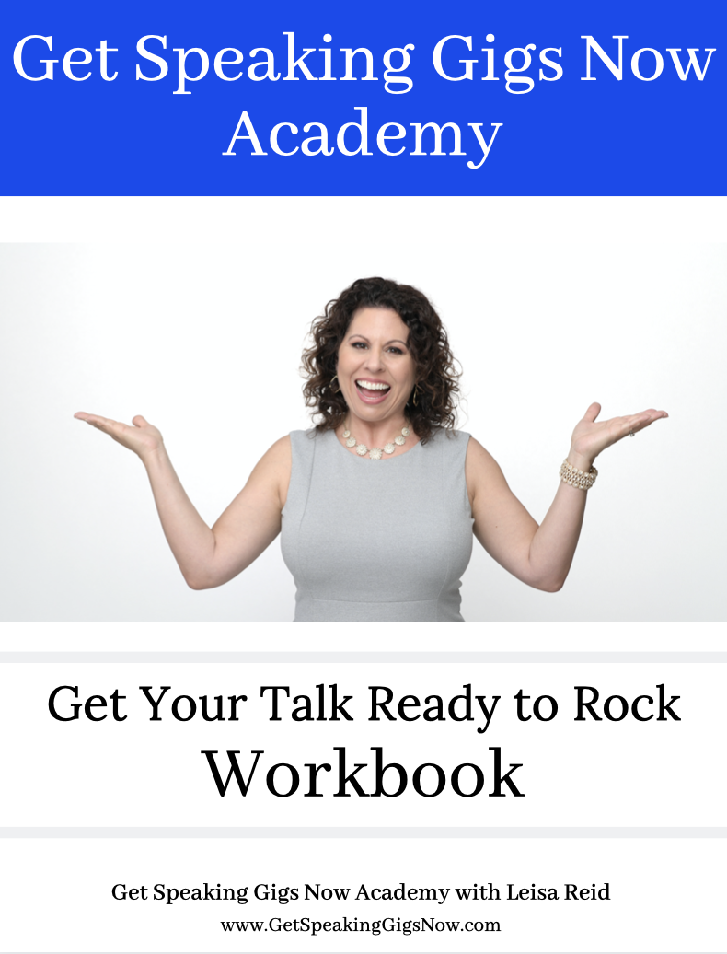

You will learn these powerful lessons:

- The Big Picture of What is Needed in a Talk
- How to REVERSE engineer the process
- How to take your expertise & make it digestible for the audience

You are ready if you are:

- Pushing speaking opportunities away because you’re working on your talk
- Scheduled to speak, but dreading it
- Want to use speaking to build your business and gain clients
- Booked to speak in the future

The Big Picture

- Reverse Engineer the process
- Know the purpose of the presentation
- Develop compelling Learning Points
- Write a brief description of the presentation
- Title
- Create an attractive / enticing speaking title
- Practice the heck out of your presentation
- Outline how you would expand/shrink it
- Repurpose it

What if your talk isn’t ready?

You will:

- PUSH away opportunities subconsciously
- Give EXCUSES to turn down speaking opportunities
- WING it (DON’T do this, I beg of you)
- MISS OUT on $$$$$
- NOT be helping the people who can benefit from your knowledge
Warning! We are not going to go in the order you think …. We are starting at the end, and will work our way back :)

What is the desired result you want at the end of your talk?

- To sell WHAT product / service?
- To build your list?
- To register people to your event?
- To get more speaking engagements?
- To get clients?
- To help people with ______?

How will your talk support that desired result?

- What will you ask for at the end?
- What are you guiding the audience to do?
- What paperwork / system do you need in place?
- Where in your presentation will this happen?

What is your CTA (Call to Action)?
Opportunity to…

- Continue your learning
- Work with you on a deeper level
- Overcome (challenge)
- Solve the problems of
- DIRECT them to the action

LEARNING POINTS

What are the 3 Pillars of Your Expertise?

The myths / problems / solutions you:

- Tell people about
- Educate your clients on
- Post on social media

Learning Point Sentence Starters

You will learn:

- How to overcome…
- The biggest myth about…
- 3 Solutions to …
- Best practices of…
- Top Secret to…
- The Mistakes…

Examples of Learning Points

1) The “What If Game”
2) The Template Experts Use to Get Booked
3) How to Turn Your Ideas into a Talk
4) Witness “Get Your Talk Ready to Rock” LIVE COACHING
Description of Your Talk

Create Your Description in TWO Sentences

SENTENCE #1:

In this (INSERT adjective) talk, (INSERT your name) shares about (INSERT summary of your Learning Points).

In this _______________ talk, _______________________ shares about ____________________________________________________________________________________________________________________________________________________________________________________

Example of Sentence #1

In this powerful and engaging talk, Leisa Reid pulls back the curtain to share expert secrets on how she helps her clients Get Their Talk Ready To Rock.

SENTENCE #2:

This talk is (INSERT adjective) for (INSERT audience type) who want to (INSERT what your ideal clients want).

This talk is ____________ for ______________________ who want to …

Example of Sentence #2

This talk is excellent for speakers, business owners and entrepreneurs who want to use the power of speaking to attract their ideal clients and make an impact on the world.

Example of ENTIRE Description:

In this powerful and engaging talk, Leisa Reid pulls back the curtain to share expert secrets on how she helps her clients Get Their Talk Ready To Rock. This talk is excellent for speakers, business owners and entrepreneurs who want to use the power of speaking to attract their ideal clients and make an impact on the world.

The Cherry on the Cake - The TITLE

What is the main theme of it all?

Examples:

- Expert Secrets …
- Transforming X into Y
- Problem You Solve
- Solution You Provide

Examples of Titles

- Get Your Talk Ready to Rock
- How to Attract Clients Easily & Consistently Through Speaking
- Speaker Secrets to Staying Consistently Booked

Get Your Talk Ready to Rock Template

Title:

Description:

Learning Points:

1.

2.

3.

Example

Title: Get Your Talk Ready to Rock

Description: In this powerful and engaging talk, Leisa Reid pulls back the curtain to share expert secrets on how she helps her clients Get Their Talk Ready To Rock. This talk is excellent for speakers, business owners and entrepreneurs who want to use the power of speaking to attract their ideal clients and make an impact on the world.

Learning Points:

- The “What If Game”
- The Template Experts Use to Get Booked
- How to Turn Your Ideas into a Talk
- Witness “Get Your Talk Ready to Rock” LIVE Coaching

Next Steps to Making an Impact with Your Message

- Filling it in with your stories / examples
- Creating a Call to Action
- Developing Your Close
- Gaining Confidence
- Designing Your Speaker Sheet
- Monetizing Your Expertise
- Finding the Gigs
- Booking the Gigs
- Keeping a Steady Stream of Bookings

PRACTICE - SUPPORT - ACCOUNTABILITY

