You will learn these powerful lessons:

- Monetization Vision
- Monetization Plan
- Multiple Ways to Monetize Your Talk
- Creating Your Monetization Menu

Your Monetization Vision:

What you’ll SEE, HEAR, FEEL, EXPERIENCE
{when it comes to money coming in from your speaking}

Imagine… you are speaking to your ideal groups of potential clients….

and you bring in new clients through speaking

Imagine how you receive the money

Imagine how you FEEL...
Giving your offer
After you step off the stage
When you are on the way home

Monetization Plan

PROFIT BY SHARING YOUR EXPERTISE

Imagine you give 1 talk a month to your desired audience.

- If you attracted one client from each talk, what would that equate to in $$$?

- Dream a little - how many clients do you imagine you could attract at each talk?

- Multiply the # of clients you could attract by the amount you charge 1 client – what do you get?

Your Estimation Formula

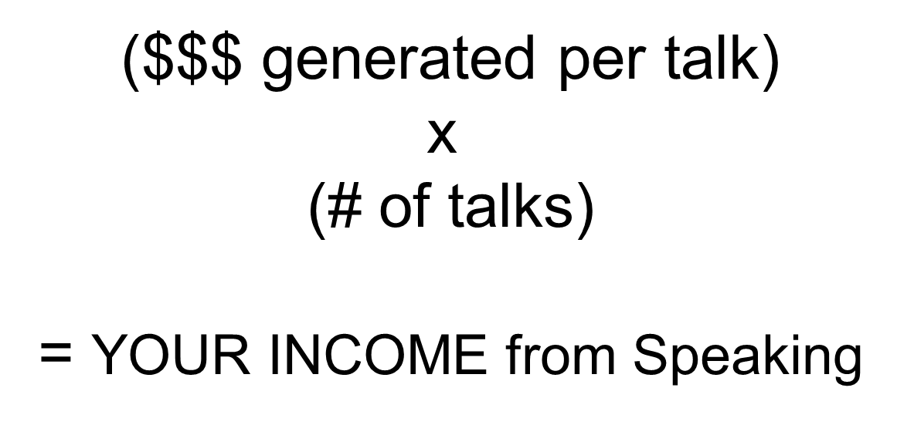

Multiple Ways to Monetize Your Talk

- Give an Offer on Stage
- Build Your List & Sell Online
- Sell Products / Services
- Get Speaking Referrals
- Schedule appointments / calls

Decide Your Methods

- Write down your top 2 choices
- Circle 1
- Do the one that gets you excited
- Do the one that you believe fits for you

THE NUTS & BOLTS

What are you selling at the talk?

- Strategy Session
- Package
- Program
- Workshop
- Event
- Retreat
- Service
- Product

How are you selling it?

- Where in the presentation?
- What are you going to say?
- What are you guiding the audience to do?
- What materials do you need?

What are you LITERALLY going to tell the audience to do?

- Handout
- Registration form
- Postcard
- Text opt-in
- Go to your table

Closing Tips

- Preplan & Prepare
- Speak Clearly & Confidently
- Be SPECIFIC in telling the audience what to do
- Select a close that feels in ALIGNMENT with You
- Only offer something that you are TRULY thrilled about
- Connect to how your offer can help people

CREATING YOUR MONETIZATION MENU

Your Monetization Menu

- The “you can’t sell” options
- The “you can sell” options

“You Can’t Sell” Monetization Tips

- ASK for clarity
- Never assume you know what they mean
- Explain how you might give an offer
- Share the value of what you offer
- Freebies – phone call / consultation, free opt-in, raffle

“You Can Sell” Monetization Tips

- Consult with organizer whenever possible
- Know your audience
- Low ticket (approx. $47 - $497)
- High Ticket ($500+)
- The more time you have, the higher you can go
- Maximize your strengths / time / resources

Your Leverage Menu

- Record the Audio
- Get Photos
- Social Media Posting
- Video taping
- Live Streaming

Always Monetize & Leverage Your Speaking

