You will learn these powerful lessons:
- Speaker Checklists
- Planning for Flexibility
- The Speaker’s Essentials

Booking a Gig Checklist
- Date
- Venue
- Address
- Contact Information
- Time the meeting starts /ends
- Time allotted for speaking
- Audio/Visual
- Additional Notes
- Approximate number of attendees expected

Booking a Gig Checklist TIPS
- Always get the organizer’s cell
- Make sure they have your cell
- Enter the address in your calendar the DAY you book it in your calendar
- Ask for any special instructions to park / get in the building
- Plan to arrive 30 minutes BEFORE the event begins
- Confirm that you can make an offer

“Day of” Checklist: Sales / Marketing
- Clarity on monetization plan
- Any registration forms / handouts
- Items / products you are selling
- Payment plan breakdown
- A way to take money
- Business Cards
- Pens / Clipboards if needed
- Banner
- Tripod for video taping
- Reminder to have someone take photos / video
- Post event to social media

“Day of” Checklist Technology
- Laptop
- Clicker
- Extra batteries for clicker
- Power Cord
- HDMI Cord / Adaptors for Projector
- Thumbdrive

“Day of” Checklist: Delivery
- Print out of your PowerPoint
- Easel / Markers
- Materials needed to deliver presentation (e.g., AV, etc.)
- Speaker Introduction Sheet
- Check travel time
- Attire

“Day of Checklist” OPTIONAL
- Music Stand
- Microphone
- Headset

Planning for Flexibility

To Sell or Not to Sell
- Get clarity when booking
- Ask questions so you are in alignment with the venue
- Have a PLAN for either way to leverage the opportunity

Differing Time Increments
- Clarify the amount of time you have to speak
- Clarify the expectation (Q&A time, what does that mean)
- Don’t try to cram in too much content
- Increase / decrease engagement
- Expand / Shrink your stories
- Always account time for your offer

Unwanted / Unexpected Obstacles
- Your time gets cut short
- The power goes out
- Hecklers
- Food is being served during your talk
- Noisy / Bad Acoustics

All the Cords You Could Possibly Need
- Extension Cord
- HDMI Cable
- Power Cord for laptop
- Phone Charger
- Adapters for Projector

The Speaker’s Essentials
- Back-up to the Back-up
- Ex. PowerPoint – thumbdrive, printed out
- Speaker Introduction (easy to read, big font)
- WHATEVER you need to monetize (forms, products, plan, etc.)

MAC Users: USB-C to VGA
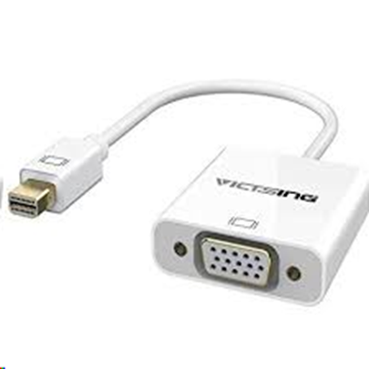

MAC Users: USB-C to HDMI

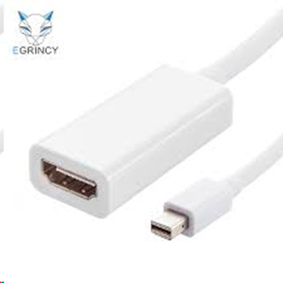

PC Users: VGA to HDMI
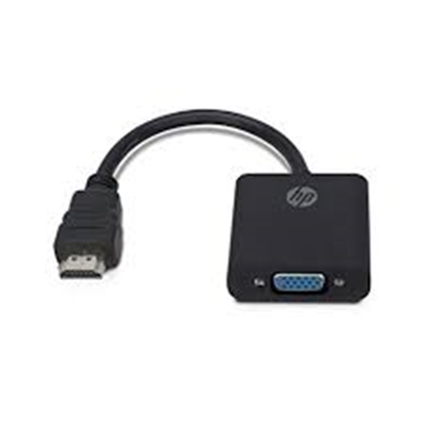

Emergency Microphone