All the TECHNOLOGY You Could Possibly Need
I created this list after realizing how many speakers are literally IN THE DARK about the technology side of speaking. I am NOT a tech-expert, but there are some BASICS you will want to know. Otherwise, you will be setting yourself up for unnecessary levels of anxiety and stress!

This is not a REQUIRED list - some of these items will be optional depending on your presentation needs. But you definitely don’t want to be caught without something that can make/break your presentation.

***It is better to have it and not need it, then need it and not have it.

- Extension Cord
- HDMI Cable
- Laptop (if needed)
- Power Cord for laptop,etc.
- Phone Charger
- Clicker (Slide Advancer)
- Back Up Batteries for Clicker
- Thumb Drive (with your presentation on it)
- Tripod for Camera / Phone
- Camera / Phone to record video / photos
- Microphone (if needed)
- Lavalier to record into phone (optional)
- Projector (most places will provide)
- Projector screen (most places will provide)
- Adapters for Projector (Necessary to bring what your laptop would need)

Adaptors for the PROJECTOR

MAC Users: USB-C to VGA
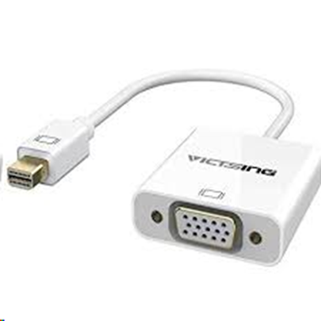

MAC Users: USB-C to HDMI
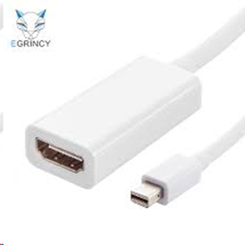

PC Users: VGA to HDMI
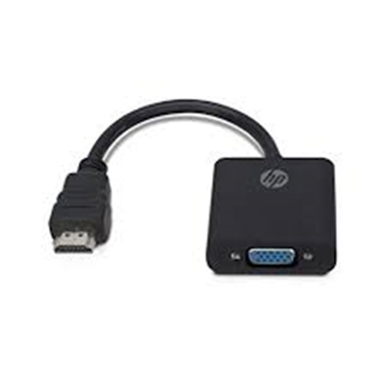

Emergency Karaoke Microphone
(bluetooth, EASY to use, no additional parts needed)
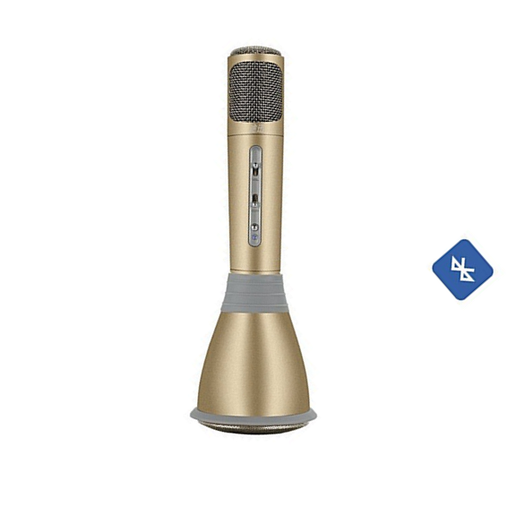

HDMI Cable

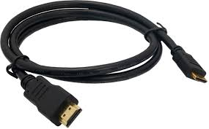

TRIPOD for I-PHONE
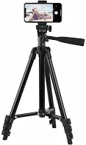

Lavalier for I-Phone
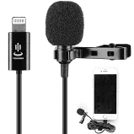

Clicker (Presentation Remote)
