You will learn these powerful lessons:
- Speaker Sheet Overview
- Designing Your Speaker Sheet
- How to Use Your Speaker Sheet

Speaker Sheet Overview

What is a Speaker Sheet?
- A sales page for you as a speaker
- Comprises all of your pertinent information
- It is for the host / meeting planner / organizer

Why do you need one?
- It gives you credibility
- Increases the confidence of the booker
- It increases YOUR confidence
- It shows that you have a plan
Simple Steps to Develop Your Speaker Sheet
- Create a FOLDER called Speaker Sheet
- Create a WORD doc in the FOLDER called Speaker Sheet
- This will house all of your items as you collect / add throughout the process
- Write a short bio (3-4 sentences)
- Get 3 strong testimonials from raving fans
- Include Your Contact Information

EXAMPLE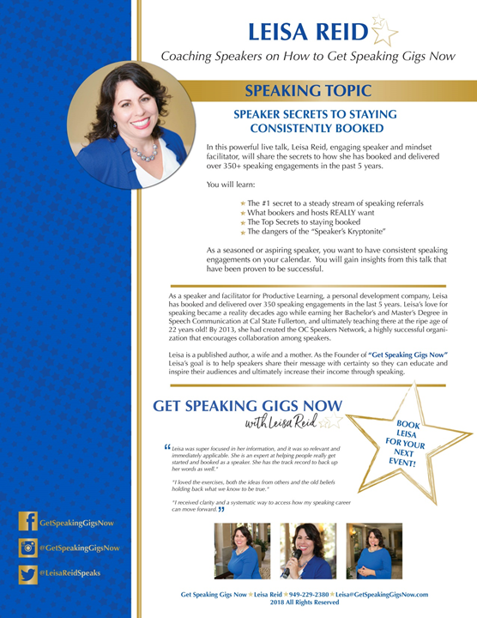

Developing Your Speaker Sheet

The Written Parts
- Your Topics
- Title of your Talk(s)
- Short Description of Your Talk(s) (2-3 sentences)
- Learning Points of Your Talk(s) (3-5)
- Brief & Captivating Bio (3-4 sentences)
- Testimonials (approx. 3)
- Call to Action

Your Bio Template

- Opening Statement

___________________ (YOUR NAME) is a __________________
and an expert in ________________________________________.

- What’s amazing about you and about what you help people with?

For example:
- How many years have you been doing it
- How much research is behind your service / product
- You’ve helped how many people
- Your product / service does xyz that’s amazing, etc.

- Closing Statement

___________________(YOUR NAME) is now engaged as a (e.g., YOUR POSITION, speaker, coach, etc.) _____________________________
specializing in _________________________________________.

Testimonials

Quality Testimonials
- Consider the source (title/position of the person)
- Concise & powerful
- Preferably regarding you as a speaker

How to Get Testimonials
- Ask your raving fans
- Ask for permission to use in your marketing
- Make it easy – write up a couple of questions for them to answer about you as a speaker

Call to Action
- Give clear direction on how they should book you to speak
- Example: For an engaging speaker to delight your audience, book (YOUR NAME) today! (xxx) xxx-xxxx

Contact Information
- Phone
- Email
- Website
- Social Media

The Design Aspect of Your Speaker Sheet

Starting the Design Process
- Search on Google
- Save the ones you like in your folder

The Design Aspects
Professional Photography
- Headshot (recommended)
- Action shot of you speaking

Branding
- Logo
- Colors
- Design style / elements

Other images
- Logos of places you’ve spoken
- Logos of publicity channels (e.g., tv, podcast, radio, etc.)
- Image(s) of your book, guidebook, products

Design Resources
- Graphic Designer
- Photographer

How to Use Your Speaker Sheet

Using Your Speaker Sheet to Get Gigs
- Mention it in your phone conversations with prospects
- Offer to send it in an email
- Send it in an email to a prospect

Leverage Your Speaker Sheet
- Digitize
- Add to Signature
- Add to Website
- Add to Social Media Sites
- Marketing tool

The Key to Completing Your Speaker Sheet is
GETTING STARTED

