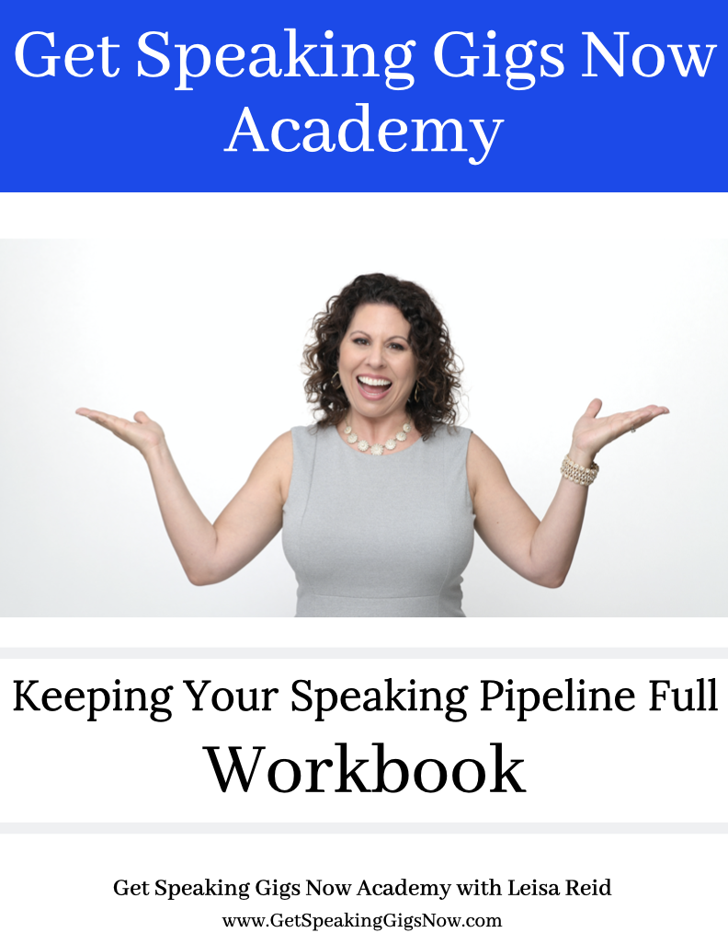
You will learn these powerful lessons:
- Networking Strategies for Speakers
- Referral Magnet Secrets
- Find Your Speaker Soulmate
- Leveraging & Repurposing

Networking Strategies for Speakers

Overall Networking Strategy
- Join 1-3 networking organizations
- Set up 1/1’s with key connectors
- Be specific in your ask
- Find out how you can help them

How to Get Specific Referrals
Think of a specific ask of where you would like to speak (must be specific) or who you are looking to meet.

For example:
- I’d like an introduction to the person in charge of booking speakers for ___________
- I’d like to speak at XYZ Chamber / Conference / Event, etc.

Follow-Up Strategy
- Enter contacts in a CRM (Contact Relationship Manager)
- Create an “opportunity” for each prospective gig
- Assign a date to follow up
- “Quick Check-In”
- Keep Strategic Partners/Connectors in Your CRM

Referral Magnet Secrets

Who are your top 10 RAVING FANS?
- Tell them your speaking goals and what you’re up to
- Personal phone call

Inner Circle
- Parents
- Kids
- Siblings
- Neighbors
- Friends
- People you patron (favorite stores, restaurants, etc.)
- Co-Workers
- Former Co-Workers
- Church / Club Friends

Your Email List
- Craft an email series (1-3 emails) to your list or warm market letting them know you are a speaker
- Ask for feedback / testimonials
- Have a contest

Email Sample to Warm Market

Hi [name],

I hope you are well.

PERSONALIZED transition sentence introducing that you are keeping them updated with your speaking...

In case you weren’t aware, I have a mission / dream / goal / passion for speaking on (YOUR TOPIC). It’s something I’m very (ENTER YOUR FEELING / IMPRESSION) about, and I’m reaching out to friends, family, and colleagues to ask for your support in spreading the word so I can make a bigger impact on the world.

If you know any (YOUR IDEAL AUDIENCES., eg., groups, organizations or conferences, business, networking) that invite outside speakers, would you mind making an introduction for me?

I've put together an email template (below) that you are welcome to use, that has the information about my speaking topic included.

Let me know if you have any questions at all, and thanks so much in advance.

Your Name / Email Signature

Speaking Referral Introduction Email

Hi _________,

One of my colleagues, YOUR NAME, is a guest speaker for groups throughout (AREA), and I think s/he could be a great fit for your group.

Below is a description of the presentation s/he leads called YOUR TALK TITLE. I've also included his/her contact information and attached his/her Speaker Sheet so the two of you can connect.

YOUR TALK TITLE

THE DESCRIPTION OF YOUR TALK - 2 sentences

3 LEARNING POINTS
- Learning Point #1
- Learning Point #2
- Learning Point #3

SHORT transition sentence that wraps up your talk...

LINK TO YOUR SPEAKER SHEET (or attach it)

Feel free to contact YOUR NAME directly if you have any questions.

Thanks!
YOUR EMAIL SIGNATURE

Find Your Speaker Soulmate

What is a Speaker Soulmate?
Someone who speaks at a similar quantity and quality as you. Someone who you like and trust who is reliable and wants to build a referral relationship with you for speaking referrals. This would be someone who is not in competition with you, but might have a complementary service to yours.

Qualifying Your Speaker Soulmate:
- What do they speak about?
- How often do they speak?
- Where do they speak (location)?
- Who is their ideal audience?
- How are their connector / referral skills?

The Speaker Soulmate Process
- Set up initial meeting (phone/in-person) to discuss plan and commitment
- Recommended meeting frequency: monthly or quarterly depending on how often you speak
- Email each other an email template introduction
- Structure for the meeting: go through past speaking engagements and determine if an introduction to the host should be made
- Implement the introductions (email / phone) so that your speaker soulmate has the red carpet rolled out for them

Leveraging and Repurposing

Leveraging Your Talks
- Get referrals AT the gig (for other speaking gigs)
- Give an option for a speaking referral on a handout or opt-in form
- Seed your services and that you speak for other groups in your talk
- Be a resource to the meeting planner
- “I know lots of qualified speakers….”
- Refer other speakers to places you’ve spoken to

Repurpose Your Talks
- Webinar
- Video Tape / Record / Photos
- Radio Show
- Podcast
- Article
- Event
- Social Media post
- Email Campaign

To be a Speaker you Need an Audience…
Let’s make it happen!

