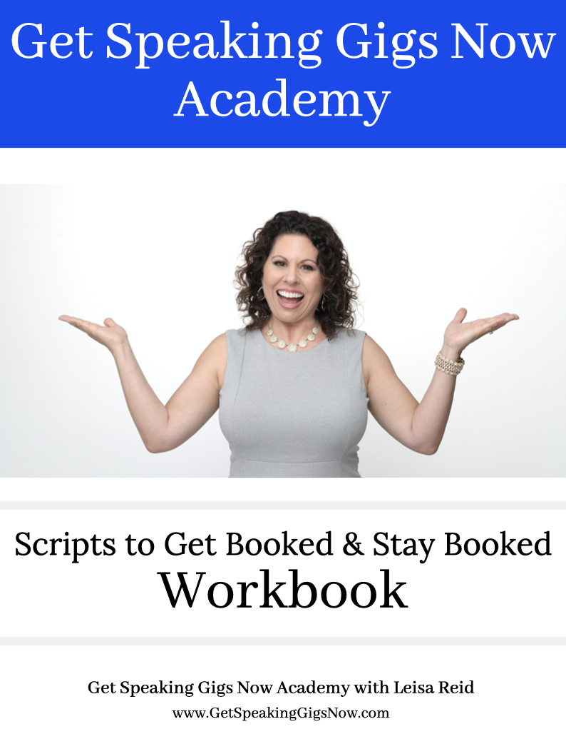

You will learn these powerful lessons:
- Email Strategy & Templates
- Phone Strategy & Script
- One-Call Close Strategy & Script

STEP ONE: Get Your Supplies Ready
Have on hand
- Prospect list with contact information
- Email template
- Speaker Sheet
- Bio ready to email
- Headshot
- Title / Description / Learning Points of talk

STEP TWO: Mentally Prepare
Set your intention
- How do you want to feel?
- What are you going to say in your email?
- What will you see?
- What type of experience do you want to have?
- What results are you wanting to achieve?

EMAIL STRATEGY & TEMPLATES

Email Follow-Up Template (#1)

Subject: Speaker for {Organization Name}

Hi {Name},

I hope you are well.

I wanted to follow-up with you about speaking for the {organization}. Are you still in need of speakers for {Year}?

I have attached my Speaker One Sheet for your convenience - there are {x} different topics you can select from - all are beneficial for {professionals} - let me know if any of those resonate for your audience.

Looking forward to connecting!

EMAIL Follow-Up Template (#2)

Subject: Quick Check-In

Hi,

I hope you are having a terrific day!

I thought I would do a quick check-in to see how you were doing setting up your speakers for (TIME of YEAR / YEAR). If there is a need for me to serve the group as a speaker let me know what dates you are looking to fill, and I will check my calendar for availability.

Past audience members of mine experience:
- Result #1
- Result #2
- Result #3

P.S. I have attached my Speaker Sheet for your convenience - there are three topics to select from with the most popular one being __________.

PHONE STRATEGY & SCRIPTS

Get to the Decision Maker Script

“Hi, {Name} - I’m not sure if you’re the one I should check-in about this, so perhaps you can help me out?

My name is {your name} and I happen to be a guest speaker in this area. I didn’t know if your group was looking for outside speakers (this year, this month, this quarter, etc.)?

Would you be the person I should check in with about that?”

Determine the Fit Script
- Tell me a little bit about the needs of your members / audience?
- What type of speakers do you like to have for the group?
- What do they enjoy learning about from the speakers?
- When does your group typically meet?
- I wasn’t sure if you were in need of a speaker (this month, quarter, year, etc.)?

Give them Confidence to Book You
- Drop in tidbits about your past speaking experience
- Let them know about a quality you bring (e.g., engaging, humorous, inspiring, etc.)

One Call Close Strategy & Script
- When are your next openings for speakers? I will check my calendar while we’re on the phone to see if I’m available.
- If they share some openings, ask them which date would they prefer for you to speak?
Ex.: “Would you prefer me to speak in April or May?”
- I happen to free (IF you are actually available) on (one of the dates that they gave you) - should I go ahead and block that off on my calendar before I get booked for another engagement?

Be Prepared for a YES
“Perfect, I am so excited to speak to your group! I’ll just need a couple of details so I have it all here and can stay organized.”

Get the Details
- Date
- Venue
- Address
- Contact Information
- Time the meeting starts /ends
- Time allotted for speaking
- Audio/Visual
- Additional Notes
- Approximate number of attendees expected

IF it’s not a YES right away...Plan for the Follow-Up
- Ask what their preference is for how you should follow-up
- How often will you follow up?
- Select a date that you can commit to

